Anna Gillespie Glass Courses

Next steps – Water

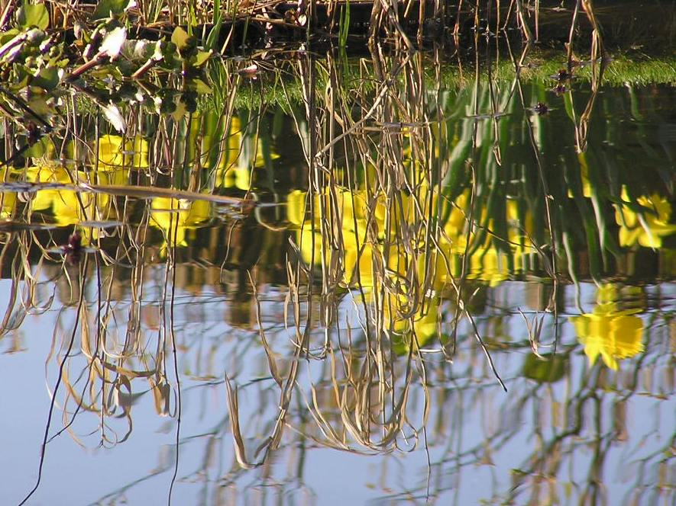
Reflections
©Anna Gillespie

A One Day Workshop

This is a follow-on course for those who have done an introduction to making stained glass.

Using the skills you learned, design and make a slightly larger panel on a watery theme – please come with some ideas or source material.

Session 1
- Revision - cutting glass
- Making thumbnail designs for a panel of up to 20 x 25 cm, with 6-8 pieces
- Selecting and cutting the glass
- Preparing the glazing board
- Leading up
- Soldering and adding hanging hooks
- Cementing

Cost
£120 for one student; £180 for two booking together. Glass cost in the region of £35 per student, depending on your choices.

If you would like to use paint, we can organise to make this a course of a whole day, plus a half day, with a firing in between.

Anna Gillespie
anna@annagillespieglass.co.uk

