Anna Gillespie Glass Courses

A Host of Golden Daffodils

A one day Introductory Workshop; one to one or one to two tuition

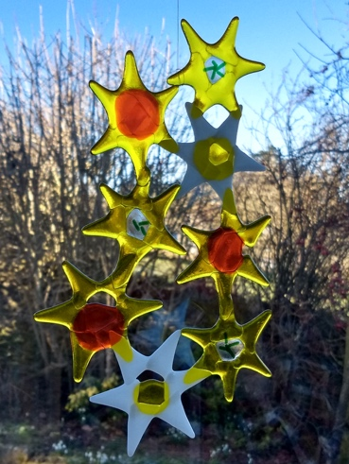

©Anna Gillespie

Learn how to create a fused glass hanging for the garden or indoors; please come with sketches or photo of Spring flowers if you wish.

- Introduction to fusing glass – a few technicals
- Introduction to cutting glass
- Making thumbnail designs for a hanging, based on spring flowers
- Selecting and cutting Spectrum glass
- Assembling ready for firing; loading the kiln
- Playtime: experiment with using window glass, frit, copper wire, foil, creating a second piece

You will need to collect your work after firing.

Cost
£120 for one student; £180 for two. Glass cost in the region of £25 per student, depending on your choices.

Please ask me about supporting you to achieve other projects you have in mind.

Anna Gillespie
anna@annagillespieglass.co.uk

